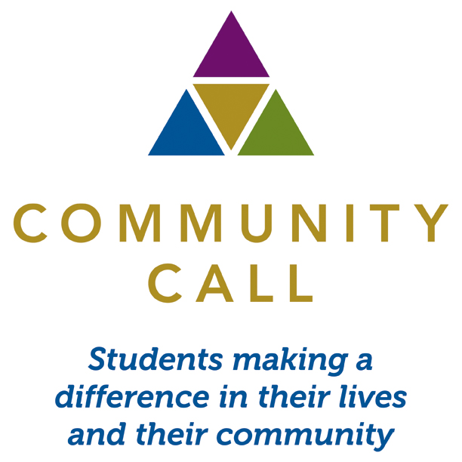

FOR IMMEDIATE RELEASE:

Media Contact:
Carolyn Edwards
Community Call
O) 617-236-1936
C) 781-789-7380
ceo@communitycall.org

COMMUNITY CALL NAMES ITS 2014 YOUNG LEADER AWARD WINNER!

Young leaders throughout Greater Boston are nominated for Community Call’s Young Leader Award to be presented by Boston City Councilor, Josh Zakim

September 30th, 2014 – BOSTON – Community Call today announced their 2014 Community Call Young Leader Award, chosen out of dozens of nominations made from across Greater Boston. All submissions from the Public were made to Community Call, an organization that utilizes community event planning as a teaching method for opportunity and at-risk Boston public high school students. The award was inspired by the work of community activist, Lenny Zakim to help identify young role models for Community Call students. Presenting the award for the second year is Lenny Zakim’s son, Boston City Councilor, Josh Zakim. The award will be presented at Pegasystems’ Stand-Up Boston Comedy Challenge at Laugh Boston, 425 Summer Street, in Boston’s Seaport District on Tuesday, October 21st as part of the evening’s activities running from 6:00 to 9:00 p.m.

The winner of the 2014 Community Call Young Leader Award is Joseph Gaeta (31 years old) of East Boston. The award recipient was chosen by a group of high school students from the Mayor’s Youth Council in Boston. The choice was made after careful consideration of nearly two dozen candidates nominated for the award ranging in age from 17 to 35 and representing a diverse group of cultures, areas of service, and neighborhoods.

Joseph Gaeta is a native of East Boston and works as the East Boston YMCA Teen Program Manager. As someone who grew up in the community and attended East Boston High School, Gaeta decided to stay in the community to help those struggling to stay in school. As a result, he developed a collaboration with East Boston High School to enroll students in a Credit Recovery Program. This program focuses on the most at-risk students and provides an opportunity for them to work at their own pace to recover credits they need to graduate. Since January of 2014, 73 students have participated completing 97 individual classes. This allowed fifteen at-risk students to graduate with the class of 2014.

In addition, Mr. Gaeta serves as the Association-wide Teen Manager for the YMCA of Greater Boston. He managed a summer program that provided free access to more than 10,000 teens across the City of Boston in more than 800 activities.

The Pegasystems Stand-Up Boston Comedy Challenge will culminate with the presentation of the Community Call 2014 Young Leader Award presented by Boston City Councilor Josh Zakim and Pegasystems Founder and CEO, Alan Trefler. More information and tickets are available at the Community Call website at www.communitycall.org.

“The Community Call Young Leader Award is an opportunity to recognize the many young leaders we are fortunate to have in the Boston area,” said Carolyn Edwards, Executive Director of Community Call. “One third of the population in Boston is under the age of 35 and there are a lot of people in this group that give back every day to make Boston stronger. We want our students to know that anyone can make a difference in the community, regardless of their background or resources”

“We are delighted to be sponsoring the Stand-Up Boston Comedy Challenge, and more importantly, Community Call and the great work they do in assisting Boston youth,” said Alan Trefler, Founder and CEO of Pegasystems. “Pega strives to be a responsible neighbor and active contributor in the communities where our employees, partners, and customers live and work. We help build stronger communities by supporting our colleagues in their charitable endeavors and by contributing to a variety of philanthropic organizations, with a special focus on helping underprivileged women and children.”

About Community Call:

Community Call's (www.communitycall.org) mission is to develop critical thinking, confidence, and self-empowerment with Boston area at-risk and opportunity high school students through community event planning. Our students are inspired to look beyond themselves and collaborate with their peers to identify a social need, develop a plan, and produce an event that benefits the broader community. Students learn organizational, business, and life skills influencing all aspects of their lives.

Our enrichment program produces a variety of entirely student-run community events providing unparalleled opportunities to learn first-hand about business and leadership and giving back to the community. By using their passion, talents, and skills, these students are more likely to believe that they can make a difference in their community while making a difference in their own lives.

About Pegasystems
Pegasystems Build for Change® Platform is the heart of Better Business Software®. It delivers business agility and empowers leading organizations to rapidly close execution gaps and seize new opportunities. Pegasystems leverages its recognized leadership in Business Process Management (BPM), Multi-Channel Customer Relationship Management (CRM), Business Rules, and Adaptive Analytics to uniquely give its clients the power to engage customers, simplify operations and Build For Change®. For more information, please visit us at www.pega.com.

####

